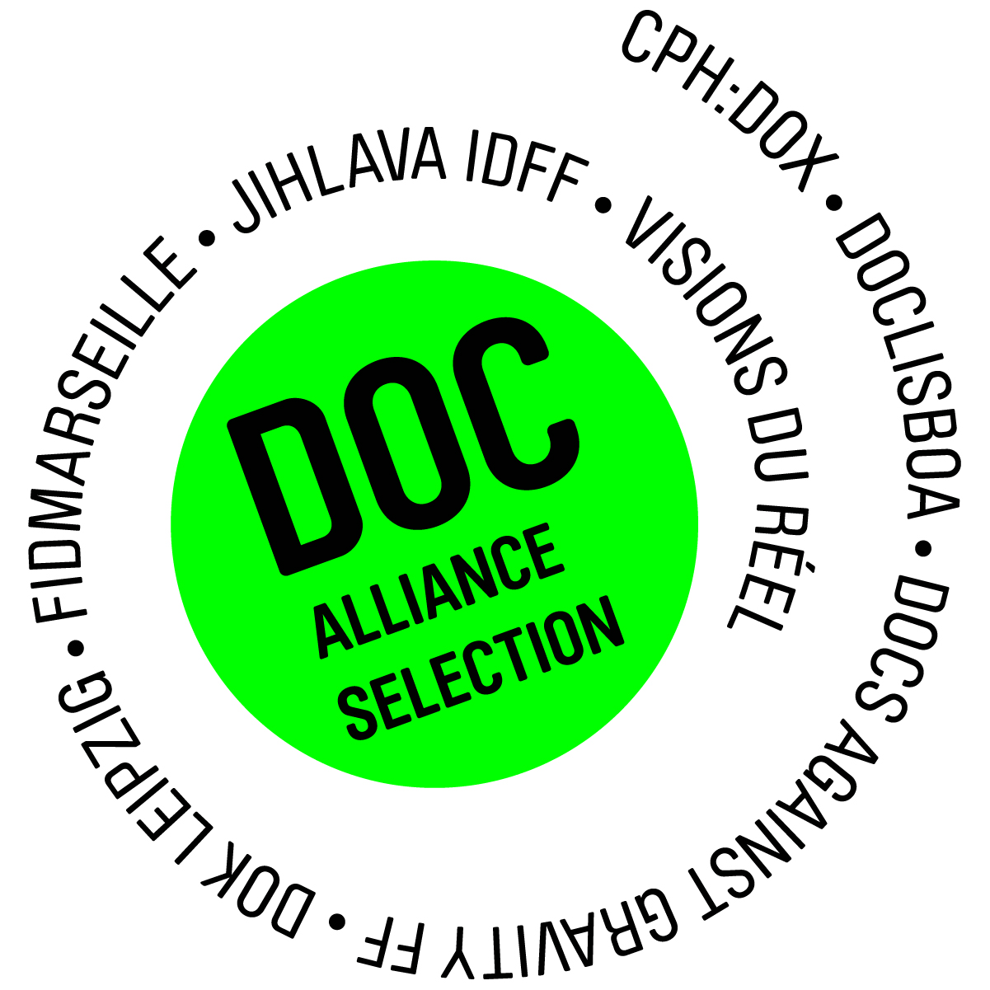
Doc Alliance Selection Award 2016: Fresh Documentary Talents at the Upcoming Ninth DAS Awards

Ever since 2008, the 7-member Doc Alliance platform of prestigious European documentary film festivals has been organising an international award intended especially for first-time directors. The Doc Alliance Selection Award helps up-and-coming filmmaking talents to put their name on the documentary map, providing a prize of EUR 5,000 to support their future projects. Nina Numankadić, manager of the festival platform, said: “Our main aim is to promote quality documentary films rather than the brand names of the individual festivals associated within the Doc Alliance network. We see the purpose of our work in joining our forces to support fresh talents and new projects.” In 2016, Doc Alliance again nominated 7 outstanding films that will be vying for the 9th annual Doc Alliance Selection Award. The name of the winning title will be announced on August 7, 2016 during an official ceremony at the Locarno International Film Festival.

***

New Faces and Projects Wanted!

The international Doc Alliance Selection Award is one of the pivotal projects organised by the Doc Alliance platform comprised of seven respected film festivals – CPH:DOX, Doclisboa, Docs Against Gravity FF, DOK Leipzig, IDFF Jihlava, FIDMarseille and Visions du Réel. Along with the online documentary portal, DAFilms.com, this year celebrating ten years of its successful activity in the area of video-on-demand offering over 1,400 carefully selected documentary films to viewers worldwide, DAS Award serves the main purpose of the festival alliance – to support and promote quality documentary films which are essential to the existence of every documentary film festival.

The prestigious award follows a simple principle: each of the seven festivals selects one nominee which they see as best representing the ultimate creative qualities, at the same time, nominating one jury member from the ranks of film critics from a country where the particular festival is based. Nina Numankadić, manager of the Doc Alliance platform, adds that the nomination itself is enormously helpful for the nominated titles. “The selected films greatly benefit from the very fact that they have been nominated. All seven Doc Alliance festivals have made an agreement to include three of the titles nominated for the annual award in their festival programme.“

Winning the Hearts of European Critics

The winner of Doc Alliance Selection Award 2016 will be announced at an official opening ceremony on August 7 at the Locarno IFF in the presence of the directors of the Doc Alliance festivals, and receive a financial prize of EUR 5,000 aimed to support their further projects, along with a commemorative plaque and the indispensable attention of media and film professionals.

The future award holder will join the prestigious club comprised of the winners of eight preceding editions including the current 2015 laureate, Iranian director Abbas Fahdel with his Homeland (Iraq Year Zero) and duo of Portuguese talents André Gil Mata (Captivity) and André Valentim Almeida (The Quest of the Schooner Creoula).

This year’s DAS Award winner will be selected by a 7-member panel of film critics, namely: Michael Bo (DE, Politiken), Gabriel Bortzmeyer (FR, Revue Débordements), Vasco Câmara (PT, Público), Piotr Czerkawski (PL, Dziennik Filmmweb.pl), Christian Junger (CH, NZZ am Sonntag), Tomas Stejskal (CZ, Hospodarske noviny), Gisela Wehrl (DE, Blickpunkt:Film).

DAS Award 2016 Nominees

- Gulîstan, Land of Roses (directed by Zaynê Akyol; CA/GE, 2016, 75 min)
Nominated by Visions du Réel
A story of present-day female Kurdish guerrilla fighters combating ISIS terrorists that unfolds on the backdrop of an investigation of the tragic death of one of them.

- Jarocin. Against the Stream (directed by Lech Gnoinski, Marek Gajczak; PL, 2015, 109 min)
Nominated by Docs Against Gravity FF
A documentary look at the history and the present of the cult Polish film festival that used to be one of the few bastions of the long-desired freedom in communist Poland.

- Fragment 53 (directed by Carlo Gabriele Tribbioli, Federico Lodoli; IT/CH, 2015, 71 min)
Nominated by CPH:DOX
A documentary exploration of the essence of war as a social phenomenon and behavioural pattern whose main protagonists have remained unchanged for centuries.

- Maybe Desert, Perhaps Universe (directed by Miguel Seabra Lopes, Karen Akerman; PT/BR, 2015, 98 min)
Nominated by Doclisboa
A close look at the slow pace of life at a psychiatric ward whose interns have been convicted of the most serious felonies.

- Steam on the River (directed by Filip Remunda, Robert Kirchhoff; SK/CZ, 2015, 90 min)
Nominated by IDFF Jihlava
A documentary probe into the original artistic worlds of a trio of world-renowned jazz musicians who fled communist Czechoslovakia.

- Maestà, the Passion of Christ (directed by Andy Guérif; FR, 2015, 60 min)
Nominated by FIDMarseille
A visually stunning film adaptation of the famous polyptych “The Passion of Christ”, freed from the constraints of camera perspective and endowing the painting with motion.

- Train to Adulthood (directed by Klára Trencsényi, HU, 2015, 79 min)
Nominated by DOK Leipzig
A film metaphor of the hardships of living in contemporary Hungary that is slowly shifting away from democracy, as symbolised by a unique relic of the communist era – a children’s train.

***

Related sources:
Information on the Award and film nominees incl. trailers
DAS Award logo for download
About Doc Alliance
Interview with Abbas Fahdel (Homeland, Iraq Year Zero), the winner of DAS Award 2015
DAFilms.com marks 10 years of existence with a new spot

Media Contact:
Andrea Pruchova
PR manager
M: +420737804449
E: andrea@dafilms.com
www.dafilms.com

Follow us on Facebook & Twitter!

